Leader

## This Team’s Current Debt

The current largest pain point is that bugs cross between code from several teams. Bugs bounce back and forth and get blocked on other teams.

## Last Meeting’s Hypothesis

* Bugs aren’t prioritized equally for all teams.
* Cross team communication and prioritization needs improved.

## This Meeting’s Goal

* **Team** is sharing results of this line of inquiry.
* **Leader** wants to improve team’s ability to own tech debt.

## Beliefs

The problem is clearly that bugs that bounce between teams and then sit there with no action for days.

## Remember Your Stance!

* Ownership is more important than the team finding the right solution immediately.
* The team has more info than you, always.
* Learning happens when there are unexpected outcomes. You don’t want everything to happen as planned or hoped!
* If the team asks for ideas, help them create options rather than give direction.

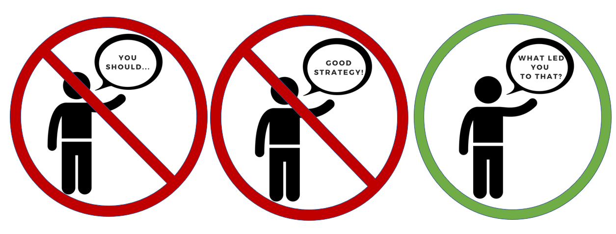

Team

## This Team’s Current Debt

The current largest pain point is that bugs cross between code from several teams. Bugs bounce back and forth and get blocked on other teams.

## Last Meeting’s Hypothesis

* Bugs aren’t prioritized equally for all teams.
* Cross team communication and prioritization needs improved.

## This Meeting’s Goal

* **Team** is sharing results of this line of inquiry.
* **Leader** wants to improve team’s ability to own tech debt.

## Beliefs

Tracking and communication experiments are simply not fixing it.

Diagnosing these bugs is hard because 1) it requires deep knowledge, 2) the information is arcane, and 3) only a few people understand the code well.

Key individuals lose time thrashing between tasks, and bugs block on them.

Everybody on both teams are trying to do the right thing.

## Remember Your Stance!

* You own this. You probably know more than the leader.
* Don’t try to convince; just try to show what is true.
* If you need a resource, ask for it. But labor is not a resource – your labor is your own and you don’t have to ask for it.

|  |  |
| --- | --- |
|  |  |